How to forward my emails to Gmail/Hotmail/Yahoo/etc
- Please do not blindly forward emails to Gmail/Hotmail/Yahoo/QQ/163/etc. If you forwarded junk mails to their server, they will block our server.
  - Please use the below method to let Gmail pull mails from our server, they will not block us in this way.
  - Hotmail/Yahoo/QQ used to allow “pull” mail, but they have removed this function in recent years. You must use Gmail if you need this feature.
- 请不要盲目地将邮件自动转发到Gmail/Hotmail/Yahoo/QQ/163等等, 这样会连垃圾邮件也转发, 他们会封锁我们的服务器.
  - 请使用以下方法让Gmail来主动抓取邮件，这样 Gmail 就不会封锁我们。
  - Hotmail/Yahoo/QQ 以前也有这功能, 但前几年已经取消了. 现在要这样用的话只能用Gmail.
- In some company, forwarding business emails to private mailboxes are not allowed. Please verify first.
- 有些公司不容许员工把公司邮件转发到私人邮箱, 请先问清楚才做.

How to connect my email account to Google Mail
- Login to Gmail
- 登录 Gmail
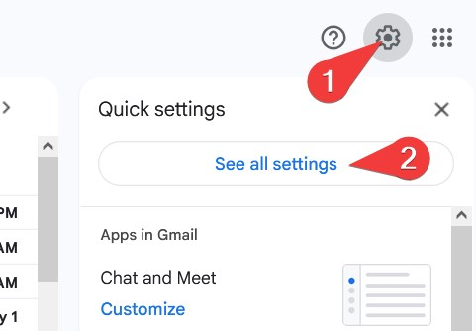
- Open Accounts and Import
- Click Add another email address
- 开设账户并导入
- 点击 “添加其他邮箱地址”
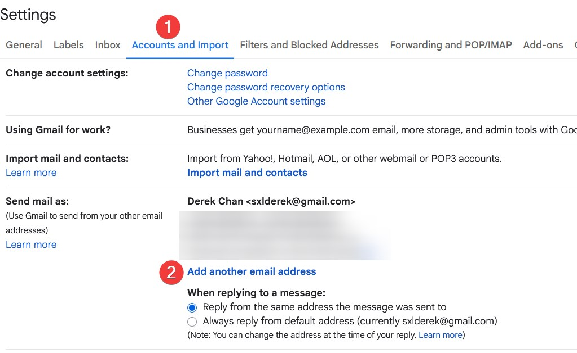
- Type your own Name, email address and then Next Step
- 输入您自己的姓名、电子邮件地址，然后下一步
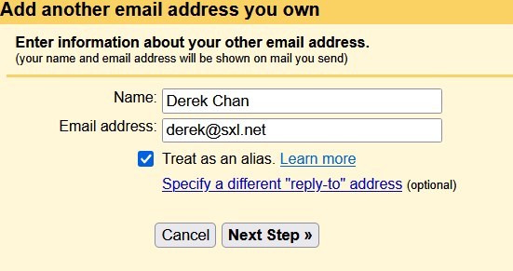
- Type your SMTP Server, usually h12.hksx.com
- Type your email address and password
- Port is 587 and use TLS for connection
- Click Add Account
- 输入您的 SMTP 服务器，通常为“h12.hksx.com”
- 输入您的电子邮件地址和密码
- 端口为“587”，并使用 TLS 进行连接
- 点击“添加账户”
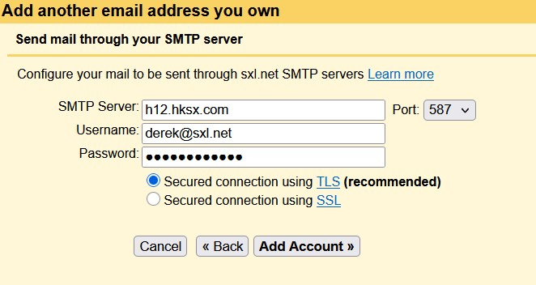
- Google will send a confirmation link to your email address
- Google 将向您的电子邮件地址发送确认链接
- Find the message to confirm it.
- 找到该邮件并确认。
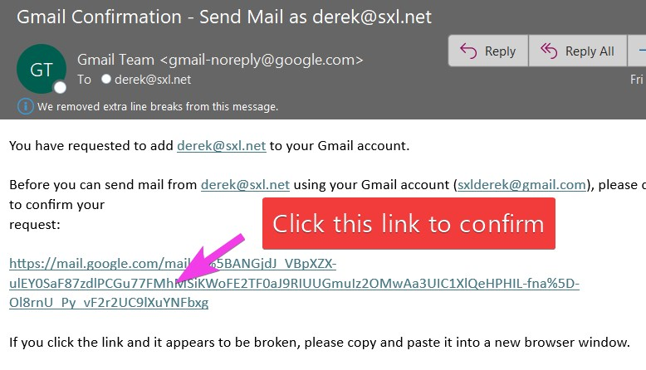
- Click Confirm again
- 再次确认
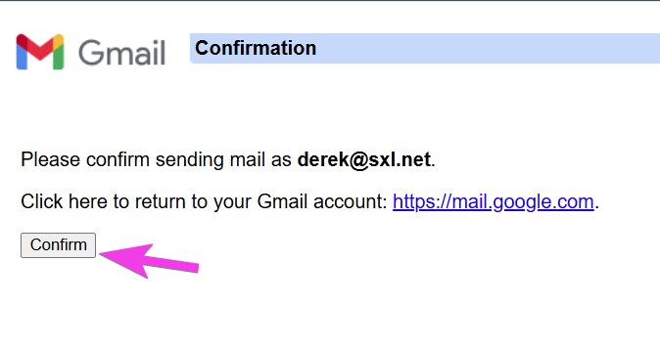
- From now on, you will receive your own email in Gmail
- 从现在起，您将在 Gmail 中收到自己的电子邮件
- When you send message from Gmail, you can choose the From address
- 从 Gmail 发送邮件时，您可以选择发件人地址
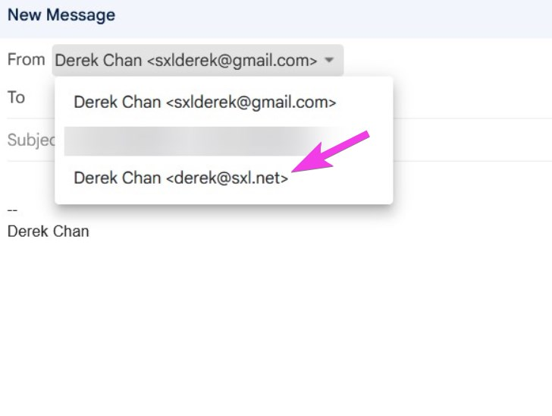
- You can add the Gmail account to your mobile phones and tablet, then you can access your business email on mobile phone.
- 您可以将Gmail帐户添加到您的手机和平板电脑，然后您就可以在手机上访问您的企业电邮。
Tracedump:
newBaseSize: 16pt
newBaseSizeInPt: 16

