中文 » 如何下載 Rustdesk 遠程

How to download Rustdesk
- Rustdesk is a software that let us control your computer to solve problems.
open Microsoft Edge or any browser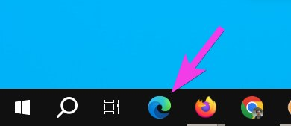
type rustdesk.com in the address bar and press Enter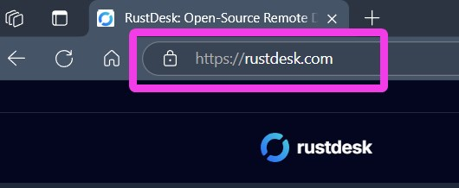
click the big blue Download button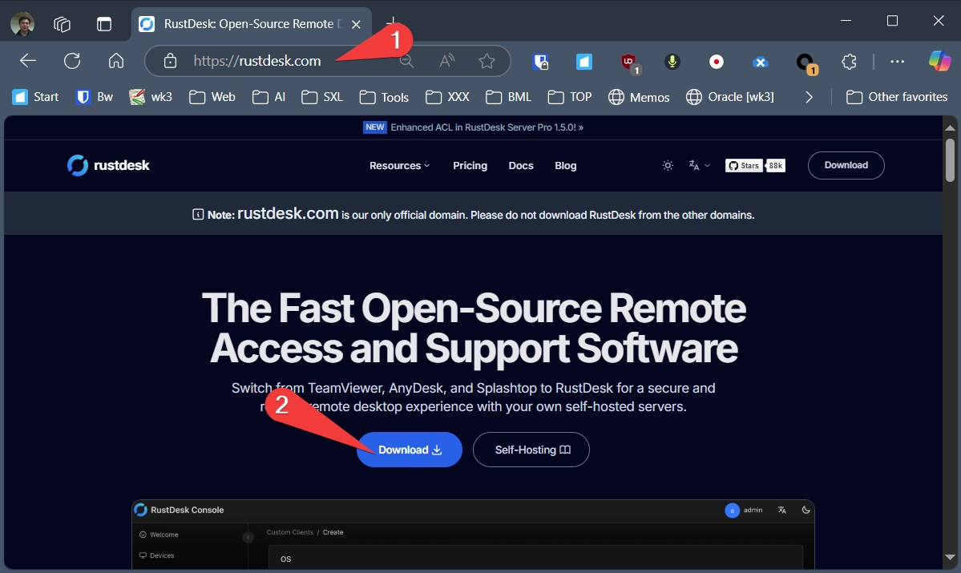
If you are using Windows Computer, click the EXE under Windows x86-64 (64-bit)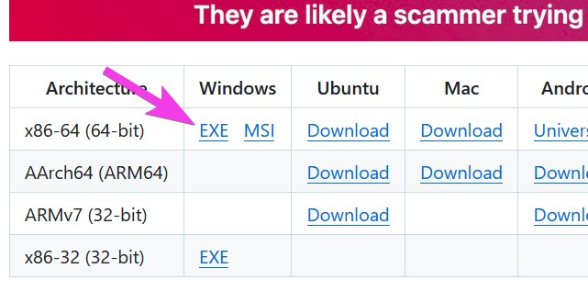
Click Open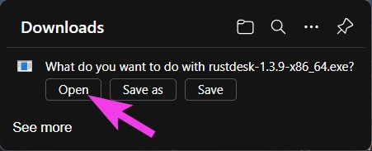
Send us your ID via Whatsapp or Email or Phone call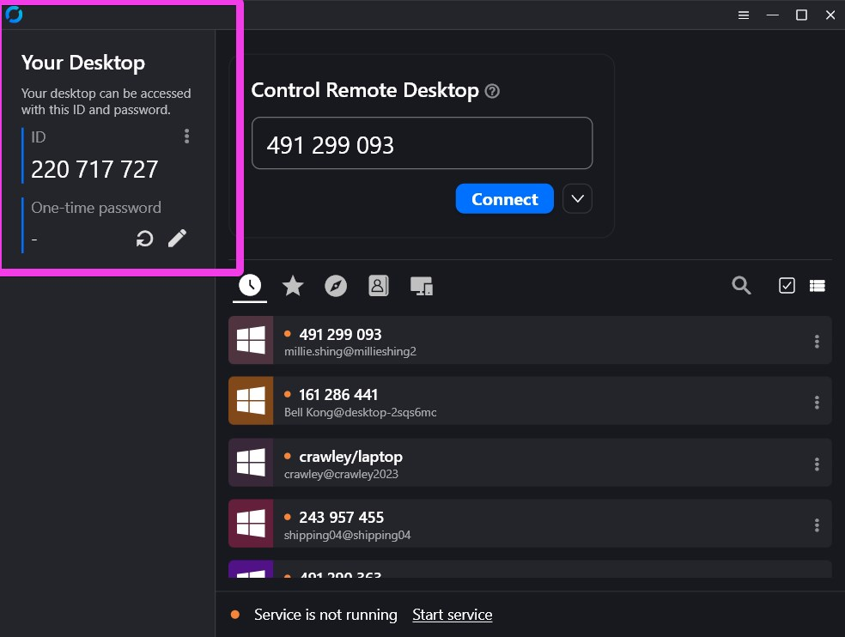
If you still have questions, please watch one of our tutorial video
- 广东话: https://youtu.be/INxaVwFpkzc
- English: https://youtu.be/1oGgf0HFeMs
- 普通话: https://youtu.be/IXSw8C2Y1zg
Tracedump:
newBaseSize: 16pt
newBaseSizeInPt: 16

