How to change email password, auto-reply, forward, etc.
如何更改电子邮件密码、自动回复、转发等。
open https://sxl.net and then click the gear and then Control Panel打开 https://sxl.net，然后单击齿轮，然后单击控制面板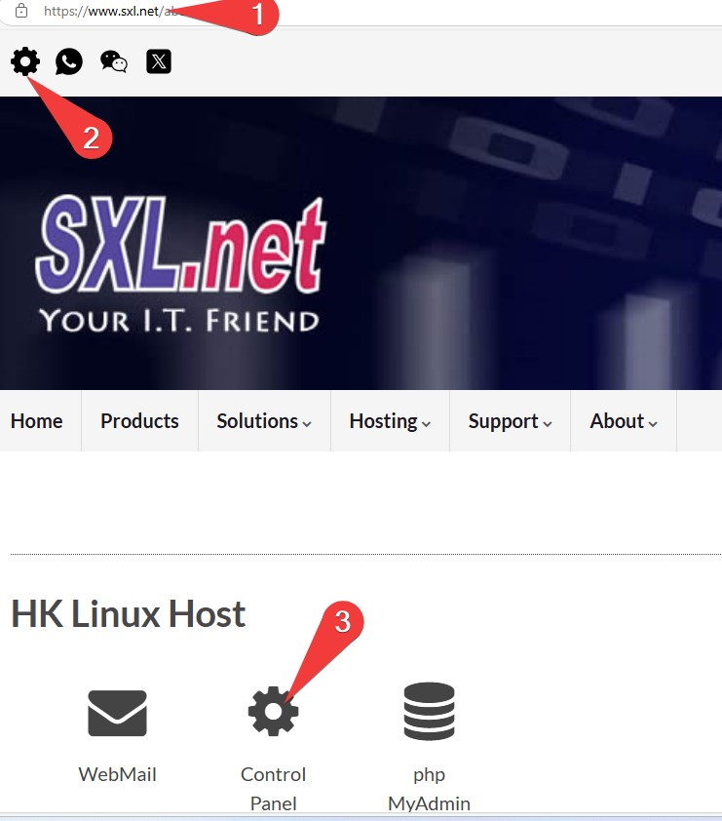
login with your email address and email password使用您的电邮地址和电邮密码登录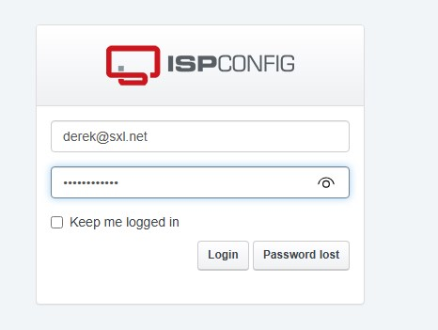
on left side of the screen, click what you want to change在屏幕左侧，单击要更改的内容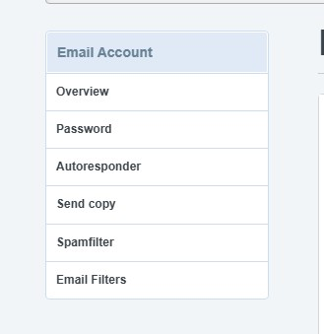
点 Password 可以改密码
After save, it take 1 minute to effective保存后, 要等1分钟才生效.
Tracedump:
newBaseSize: 16pt
newBaseSizeInPt: 16

