How to open WebMail
open SXL.NET in a browserclick the Gear button on the top left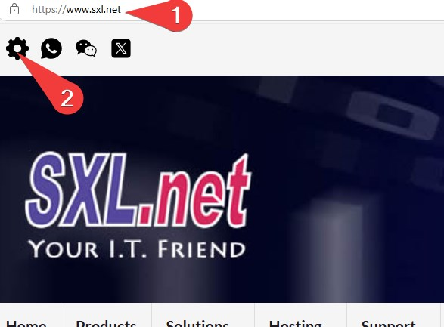
click the WebMail icon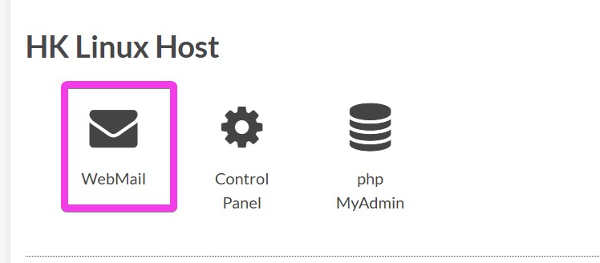
login with your full username and password
if you are using your private computer, click Save Password so that you don't need to type password everytime.
to change your Display Name and Signature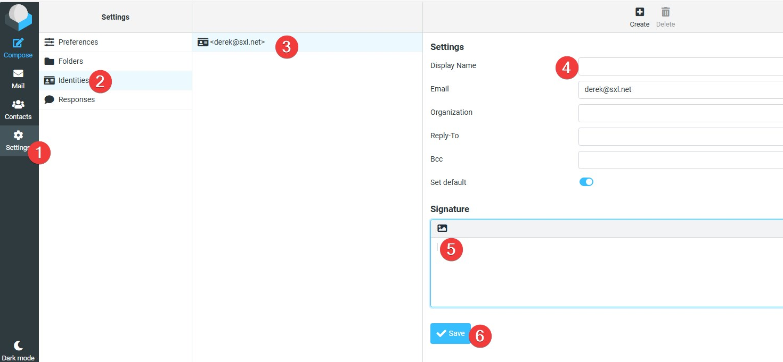
Tracedump:
newBaseSize: 16pt
newBaseSizeInPt: 16

