How to open WebMail on mobile phone
Our WebMail also works fine on mobile devices (phone and tablets and TV box)
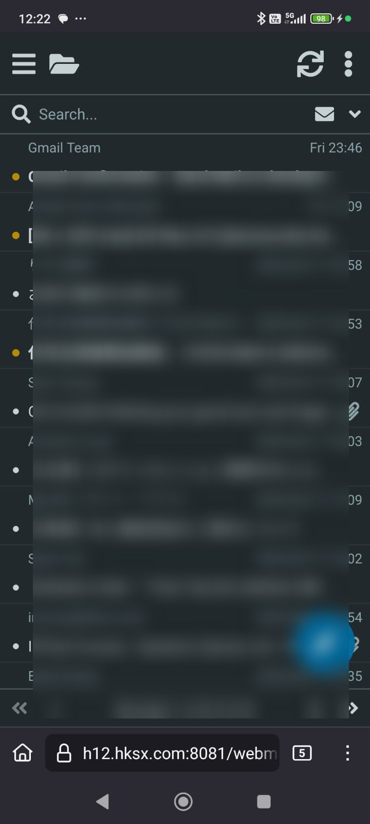
Tracedump:
newBaseSize: 16pt
newBaseSizeInPt: 16

