How to connect my email account to Google Mail
Login to Gmail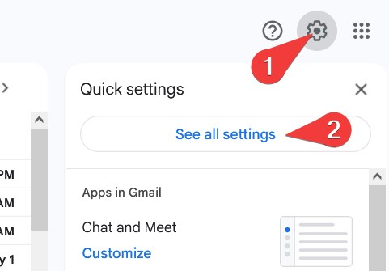
Open Accounts and ImportClick Add another email address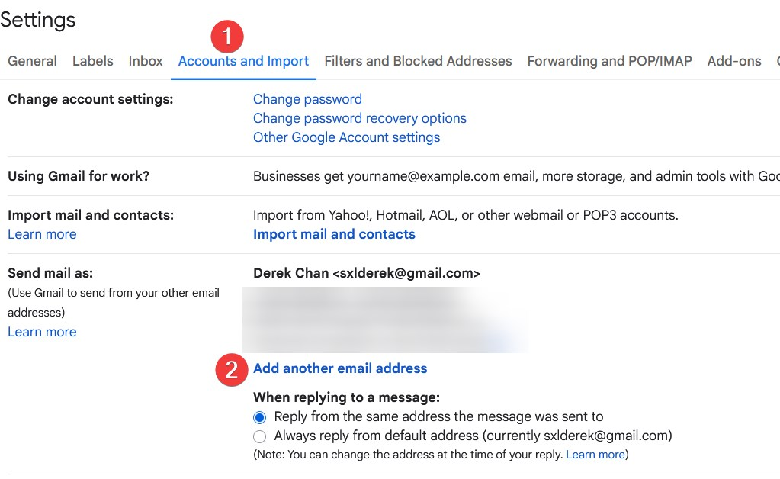
Type your Name, email address and then Next Step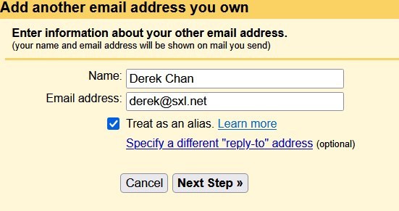
Type your SMTP Server (usually h12.hksx.com)Type your email address and passwordPort is 587 and use TLS for connectionClick Add Account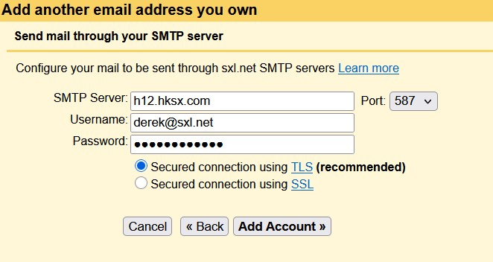
Google will send a confirmation link to your email address
Open your Outlook or Webmail to confirm it.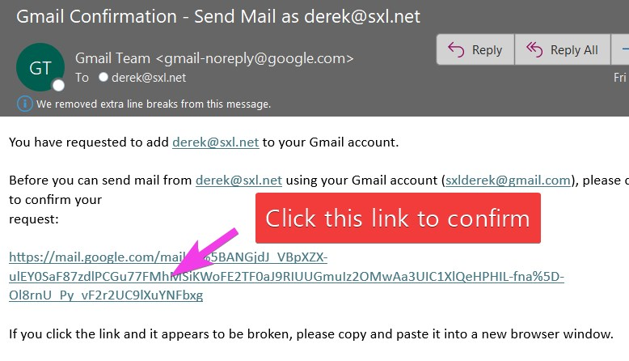
Click Confirm again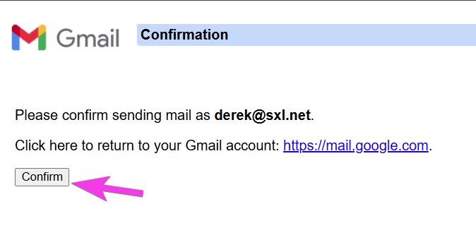
Tracedump:
newBaseSize: 16pt
newBaseSizeInPt: 16

