How to setup email on iphone (advanced settings)

Change connection SSL and Ports
- Most user don't need to do this
- Open Settings > Passwords & Account
- Tape the account you want to change
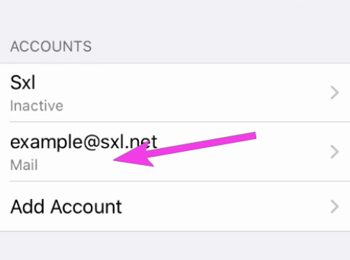
- Tap SMTP server
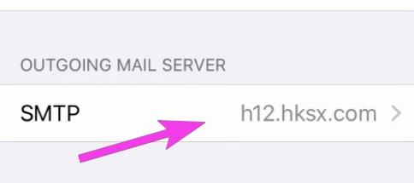
- Tap Primary server
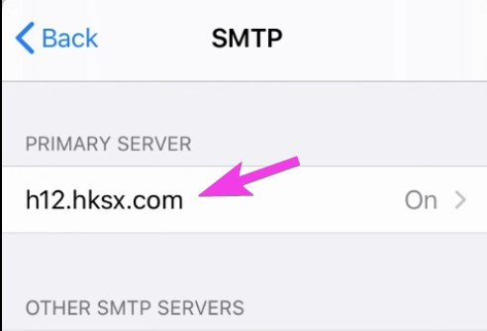
- Turn on SSL and change Server Port to 587
- This is an example only, you may need to try different settings.
  - see * h12_mail_server_connection_methods
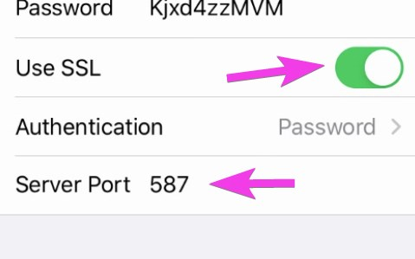
- Go back to the previous mail account page
- click Advanced
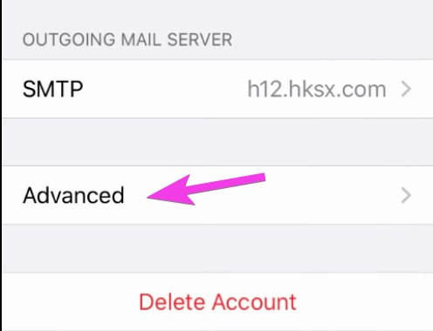
- Change the Incoming settings
- This is an example only, you may need to try different settings.
  - see * h12_mail_server_connection_methods
- POP server should look like this
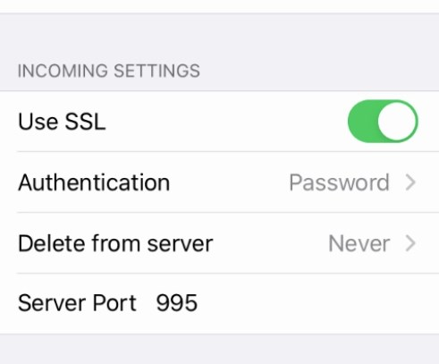
- IMAP server shoud look like this
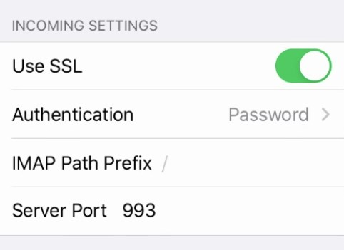
Tracedump:
newBaseSize: 16pt
newBaseSizeInPt: 16

