How to open WebMail
- open https://mail.sxl.net in a web browser
- login with your full email address and password
- if you are using a private computer, click Save Password so that you don't need to type password everytime.
- to change your Display Name and Signature
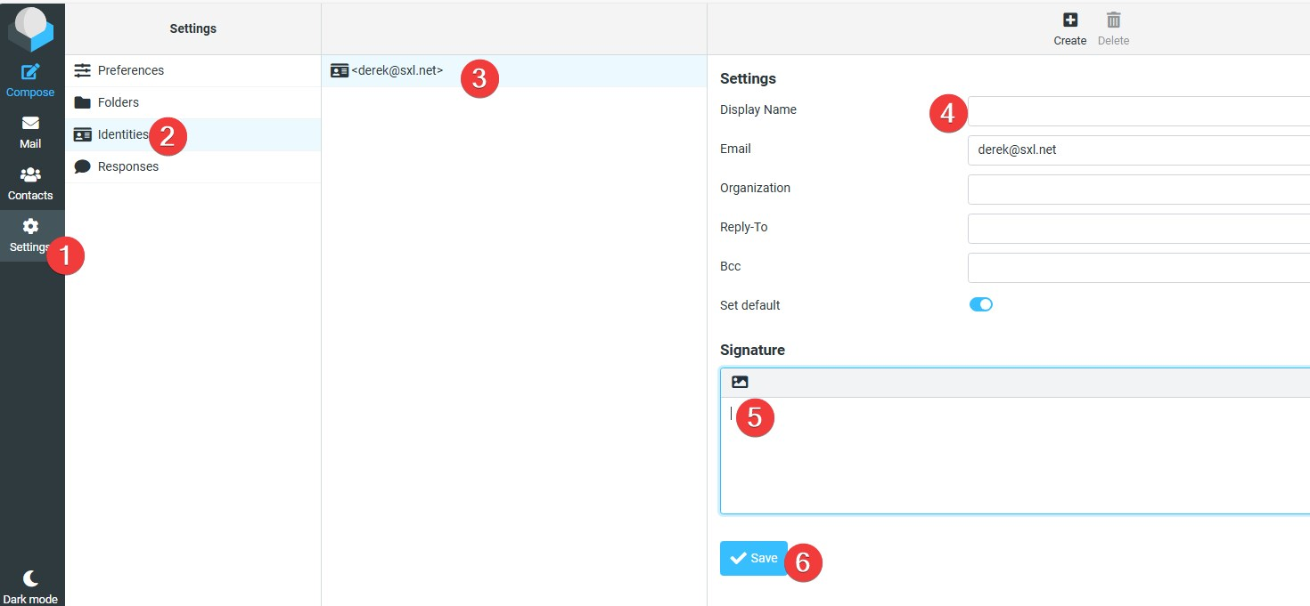
Tracedump:
newBaseSize: 16pt
newBaseSizeInPt: 16

