How to free up spaces on server mailboxes
- delete a few large message rather than delete a lot of small mails

Clean up Junk and Trash
First, login to webmail (see how_to_open_webmail_on_computer)
Select the Junk mailbox, click the mailbox menu on top, select Empty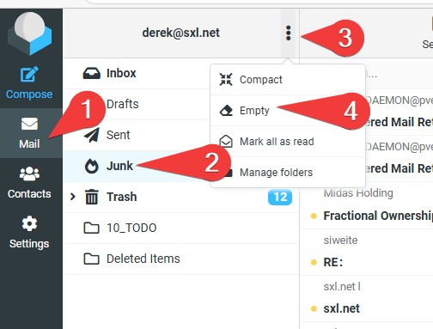
Do it again for the Trash mailbox

Clean up Inbox and Sent
Select Inbox
- Click Options on top
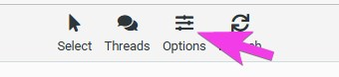
- Sort by Size, Decending
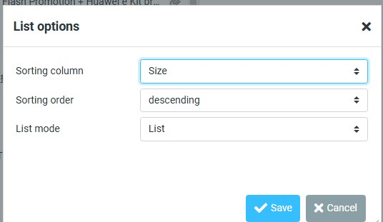
- While holding the Shift or Ctrl, select some biggest messages you want to delete
- click the Delete button
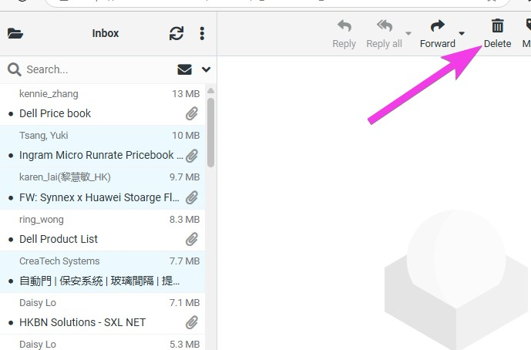
- Do the same for Sent folder
- After deleted messages, empty the Trash folder
- After few minutes (not immediately), notice the free space changed
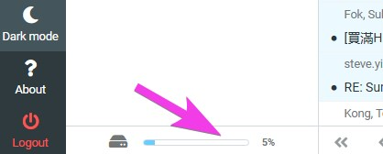
Tracedump:
newBaseSize: 16pt
newBaseSizeInPt: 16

