中文 » 如何下載 Anydesk安力桌 遠程

How to download Anydesk
Open Microsoft Edge

Type anydesk.com in address bar (not search bar) and press Enter
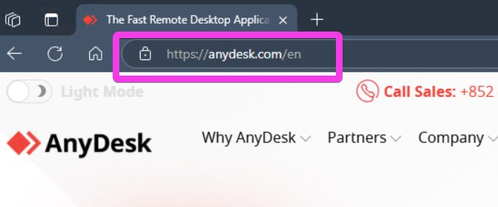
click Download Now

click Open
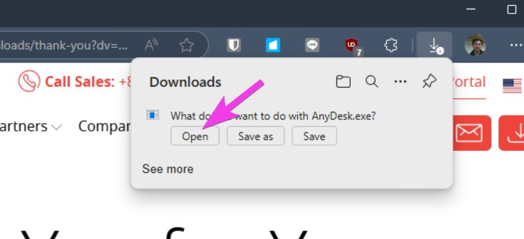
Send us your ID via Whatsapp or phone
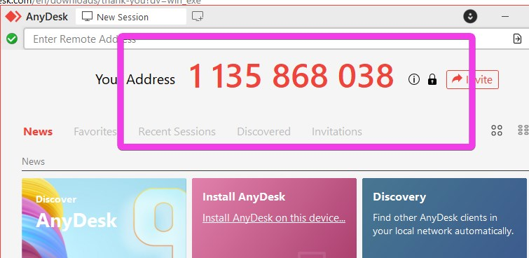
If this screen appears, click Allow
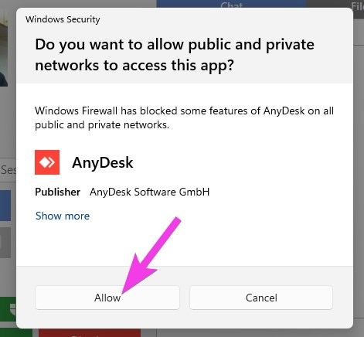
When we connect to your computer, click the Bigger Accept
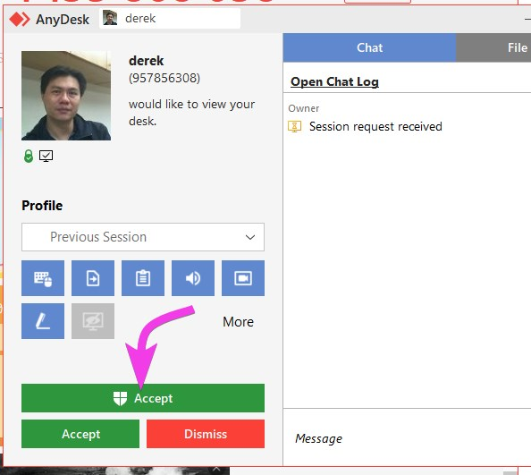
If this screen appears, click Yes
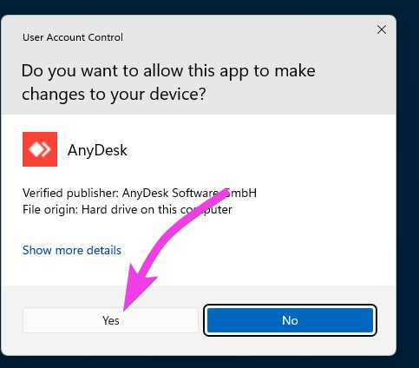
Tracedump:
newBaseSize: 16pt
newBaseSizeInPt: 16

