setup iphone english
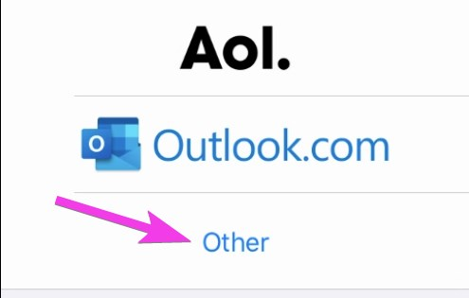
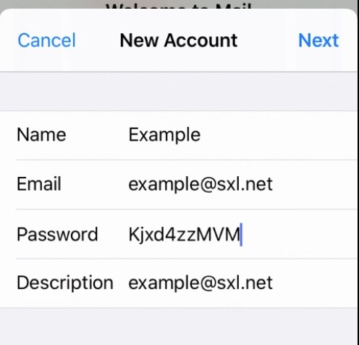
- In Incoming Mail Server
  - Host Name h12.hksx.com
  - User Name (input your own email address)
  - Password (input your own password0
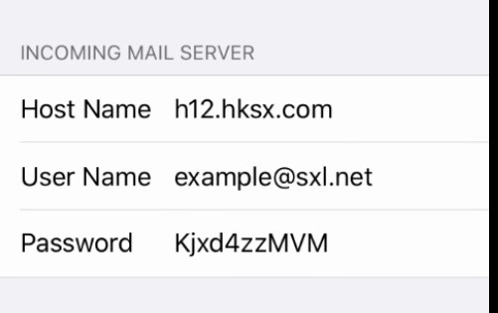
- In Outgoing Mail Server
  - Host Name h12.hksx.com
  - User Name (input your own email address)
  - Password (input your own password0
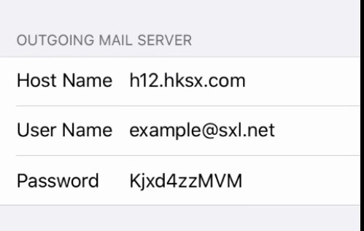
- tap Save
On existing account
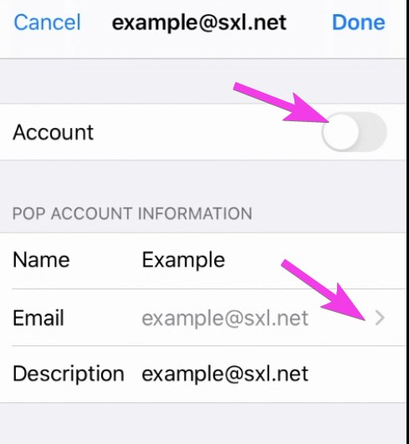
tap the SMTP server name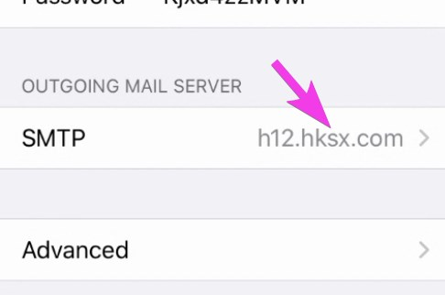
- tap the primary server
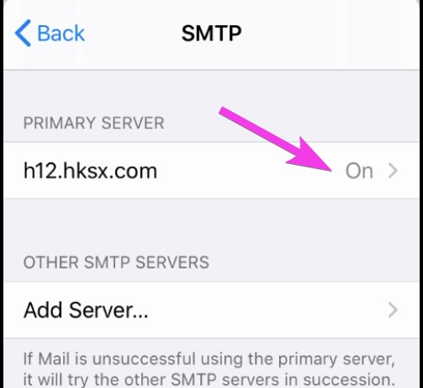
- Check Outgoing SMTP settings
  - Use SSL is on
  - Authentication is Password
  - Server Port is 587 (or 465)
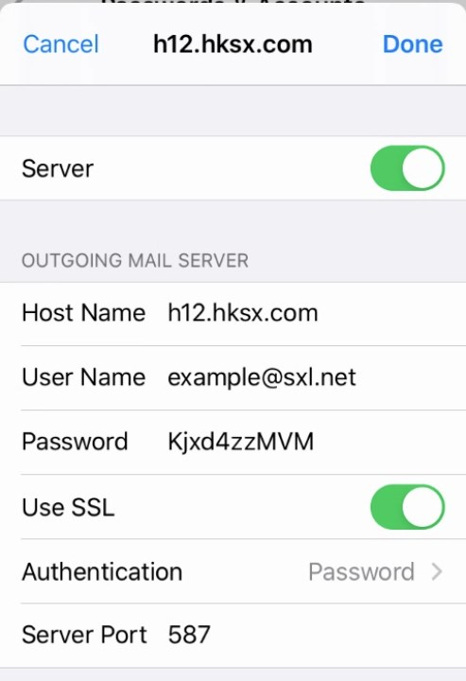
- Check Incoming POP settings
  - Use SSL is on
  - Authentication is Password
  - Delete from server is Never
  - Server Port is 995
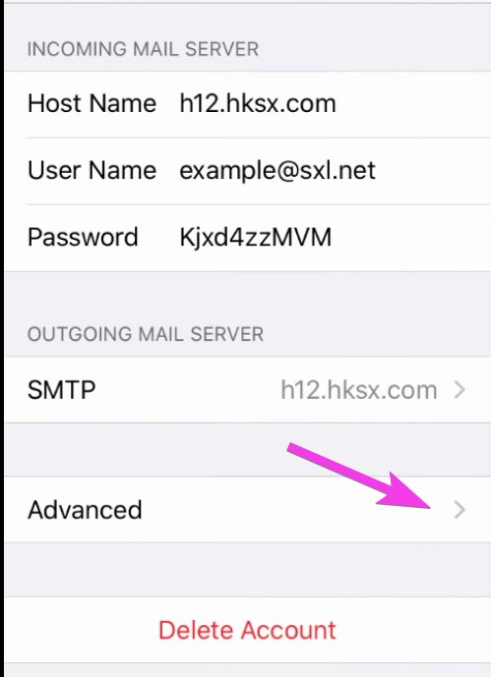
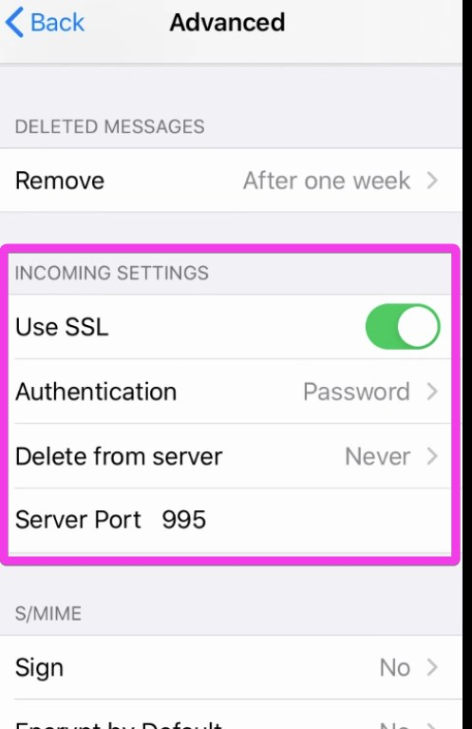
Tracedump:
newBaseSize: 16pt
newBaseSizeInPt: 16

