setup iphone english

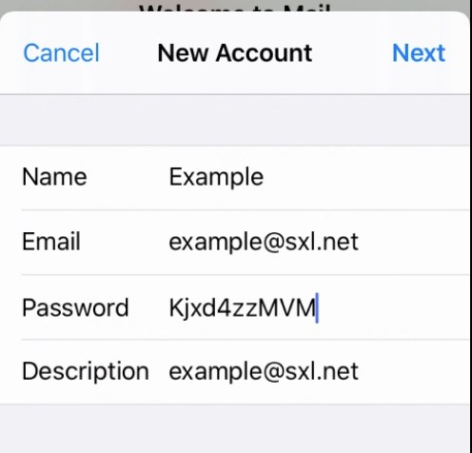
Tracedump:
newBaseSize: 16pt
newBaseSizeInPt: 16

