setup email on iphone
Open Settings > Mail > Accounts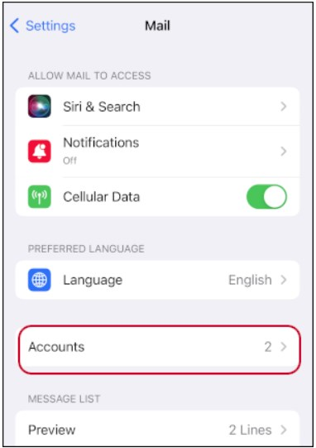
Tap Add Account > Other > Add Mail Account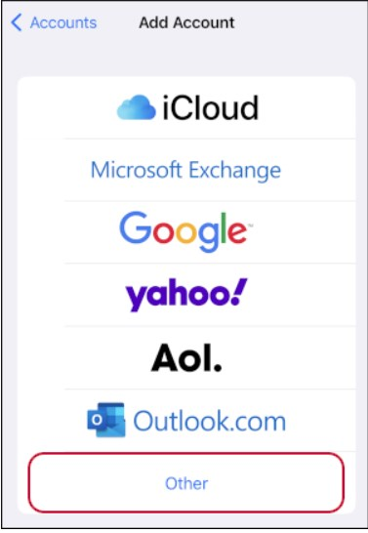 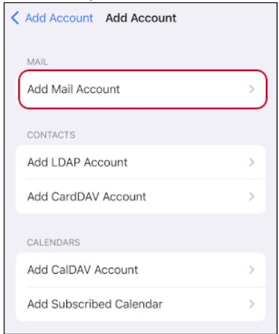
Input your Name, Email Password and then tap Next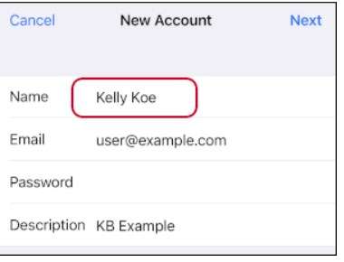
Select IMAP or POP (please read: what_are_pop3_and_imap_which_one_should_i_use)
- Hostname, User Name and Password must be input in both Incoming and Outgoing Server sections..
- Hostname is usually h12.hksx.com (or ask your email administrator for correct server name)
- User Name is your email address
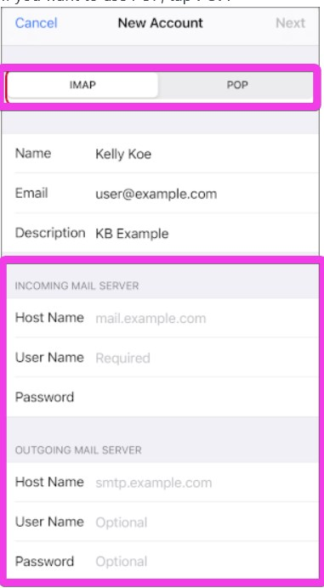
Tap Next > Save
Tracedump:
newBaseSize: 16pt
newBaseSizeInPt: 16

