How to download Rustdesk remote control software
Rustdesk is a software that let us remotely see and control your computer.
open Microsoft Edge or any browser打开 Edge 或任何浏览器
type https://rustdesk.com in the address bar and press Enter在网址栏 (不是搜索栏) 输入 rustdesk.com 然后按输入(回车)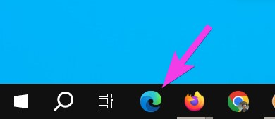
click the big blue Download button点击 蓝色 下载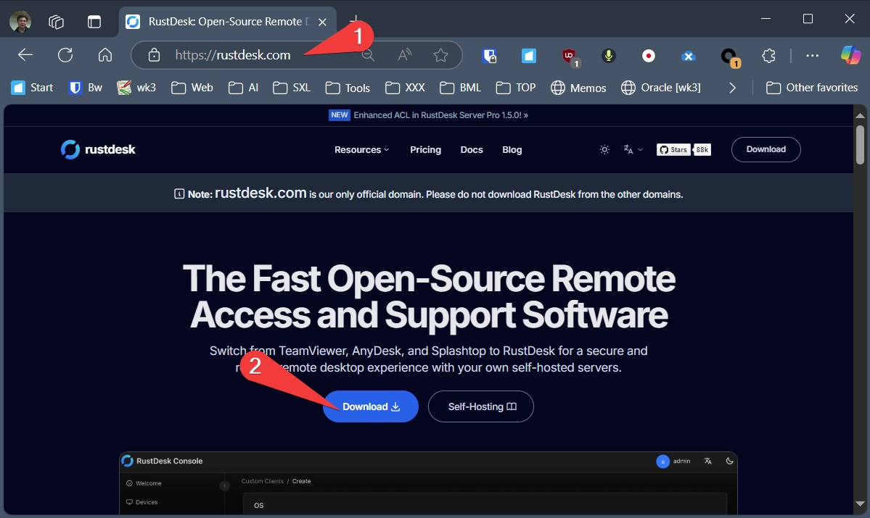
If you are using Windows Computer, click the EXE under Windows x86-64 (64-bit)如你使用Windows系统, 点击Windows x86-64 (64-bit) 里的 EXE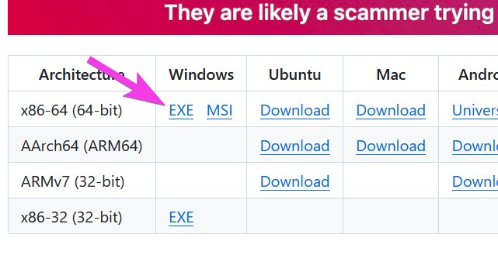
Click Open点击打开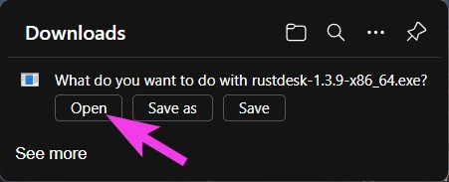
Send us your ID via Whatsapp or Email or Phone call把你的ID用微信或其他方式告诉我们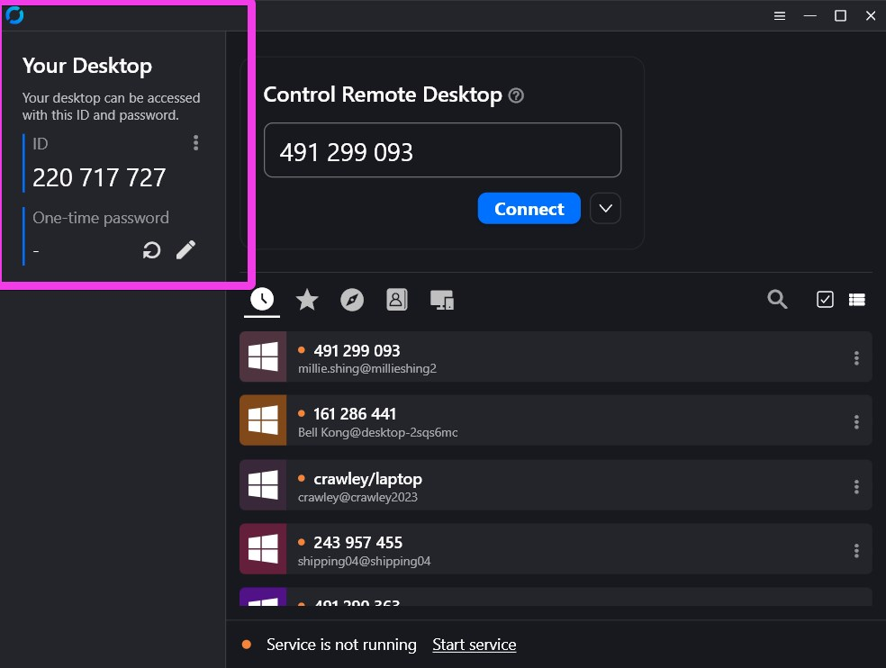
If you still have questions, please watch one of our tutorial video如还还有问题 请看下面其中一个教学视频
- 广东话: https://youtu.be/INxaVwFpkzc
- English: https://youtu.be/1oGgf0HFeMs
- 普通话: https://youtu.be/IXSw8C2Y1zg
Tracedump:
newBaseSize: 16pt
newBaseSizeInPt: 16

