Migrate Outlook IMAP accounts to new email server
- close Outlook
- Right-click on Start and then click Run
  - 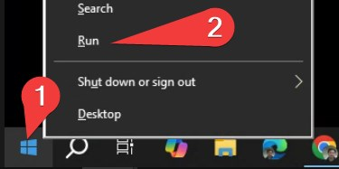
- type control and then click OK, to open Control Panel
  - 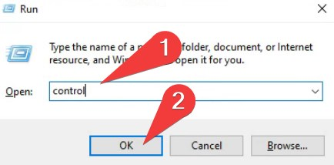
- In control panel, search mail, then click on Mail (Microsoft Outlook xxxx)
  - 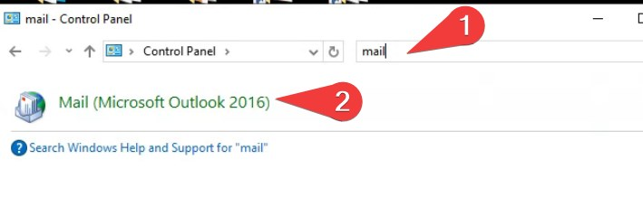
- Click Email Accounts
  - Make sure your account is IMAP type
  - If you have multiple email accounts, some POP3 and some IMAP, make sure we do this operation on IMAP accounts only.
  - Please read this for Migrate Outlook POP3 accounts
  - 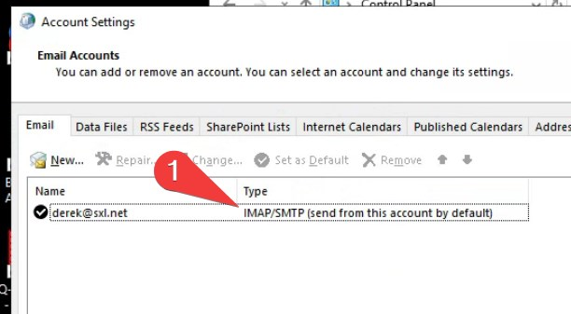
- For IMAP accounts, we must backup existing emails before changing account settings
- Open Outlook, click File > Open & Export
  - 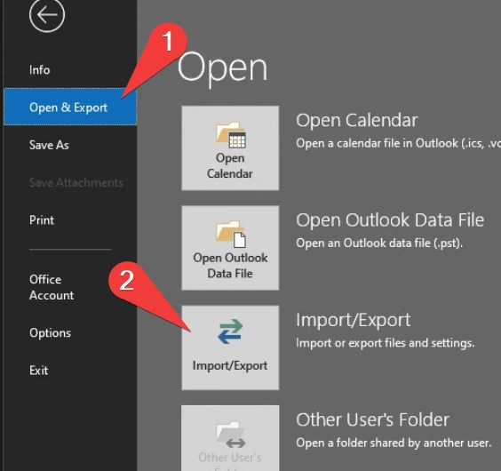
- Choose “Export to a file” and then click Next
  - 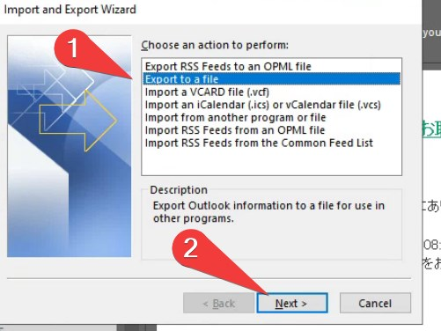
- Choose “Outlook Data File (.pst)” and then click Next
  - 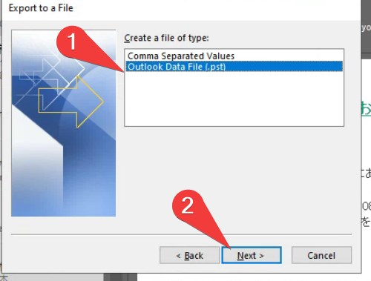
- Choose the IMAP account and then click Next
  - 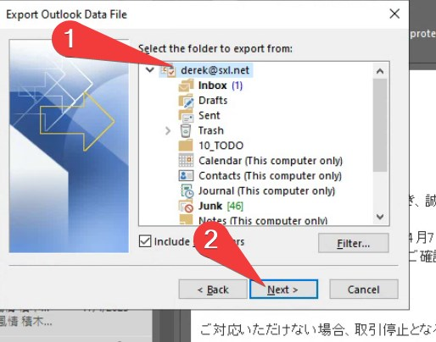
- In Save exported file as, click Browse, and give a name to your backup file (I name mime as derek-backup.pst)
  - 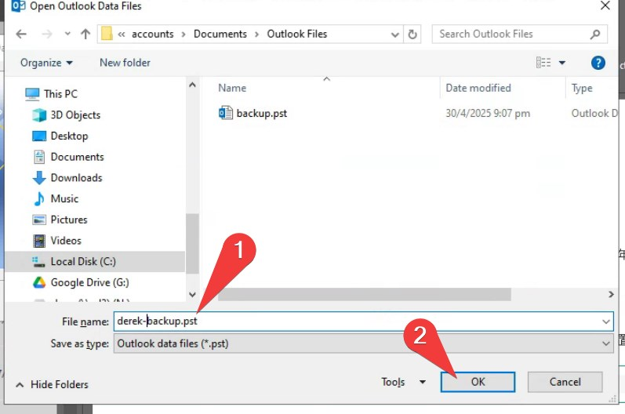
  - If you have multiple IMAP accounts, it is important to rename the backup file, so that later export will not overwrite previous ones.
- Click Finish to start the export
- Do not input any password, just click OK.
  - 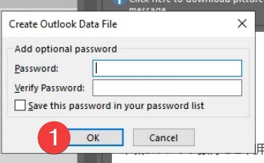
- After export is finished, we begin to change the server settings.
- Close Outlook
- Go back to the previous Control Panel > Mail settings
- change both Incoming and Outgoing server to h12.hksx.com
- and then click More Settings
- 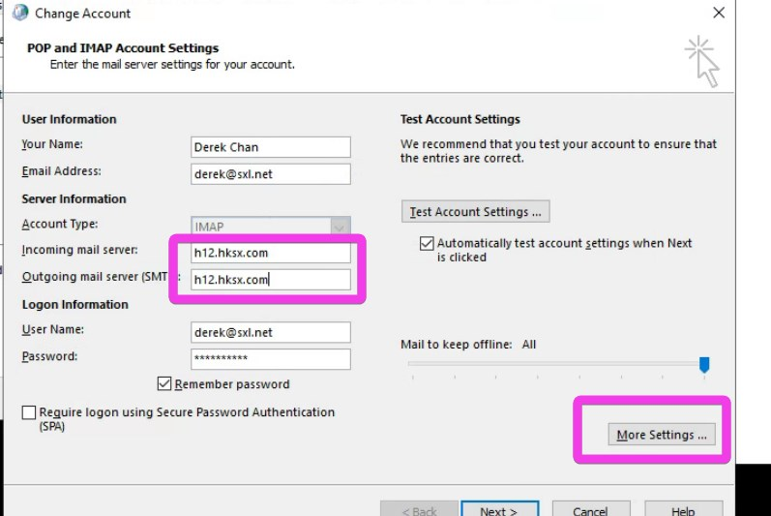
- make sure Outgoing Server is set to > Use the same settings as my incoming mail server (this is same as before)
- 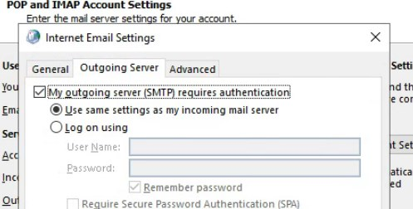
- On the Advanced Page
  - set Incoming server (IMAP) port to 993 and SSL/TLS
  - set Outgoing server (SMTP) port to 465 and SSL/TLS
  - If your computer / outlook is older than 10 years, or you are using different product, you may need to try different port.
    - Incoming Port 993 SSL, or Port 143 None SSL
    - Outgoing Port 465 SSL, or Port 587 STARTTLS, or Port 25 None-SSL
    - Click OK and Next
- Outlook will test connection, normally you will see this:
  - 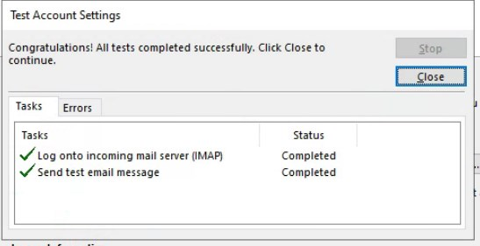
- If cannot pass this test, you can
  - 1. make sure your password is correct (try login WebMail)
  - 2. try different connect ports/SSL combinations (see above)
- Click Close and Finsih
- Open Outlook again
- After Send/Receive once, you will see all your previous emails disppeared. but don't worry.
- We have to import the previous backup now.
- Click File > Open & Export > Import/Export
- 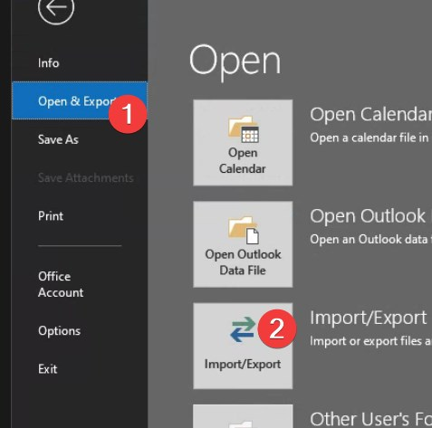
- choose “Import from another program or file” > Next
  - 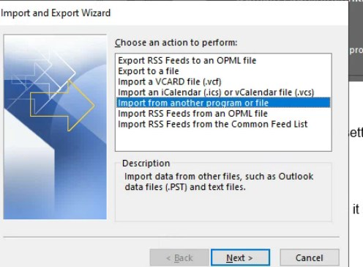
- choose Outlook Data File > Next
  - 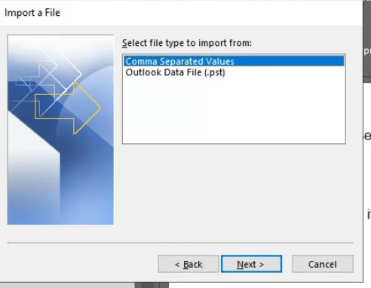
- Browse to the previous backup file > Next
  - 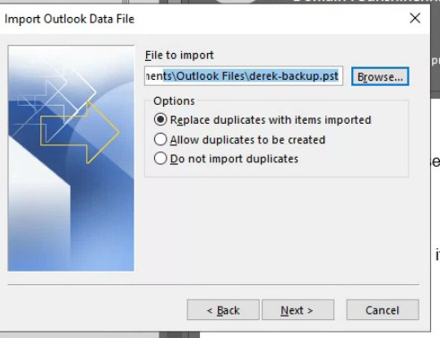
- Choose Import to the same folder > Finish
  - 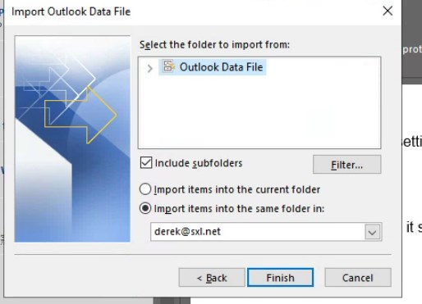
- Wait until import finished
- All your previous emails come back.
- If you have other computers, laptop, hand phone using the same IMAP account
  - you only need to delete the previous account, and then add a new account with new server settings.
  - all your emails will come back.
Tracedump:
newBaseSize: 16pt
newBaseSizeInPt: 16

