How to free up spaces on server mailboxes
- delete a few large message rather than delete a lot of small mails

Clean up Junk and Trash
First, login to webmail (see How to open WebMail on computer)
Select the Junk mailbox, click the mailbox menu on top, select Empty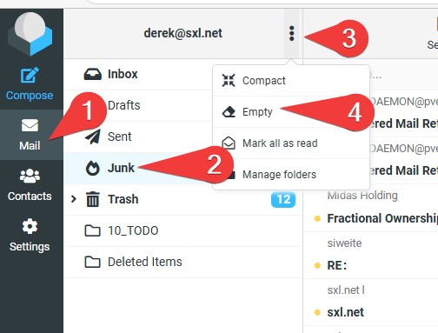
Do it again for the Trash mailbox

Clean up Inbox and Sent
Select Inbox
- Click Options on top
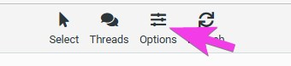
- Sort by Size, Decending
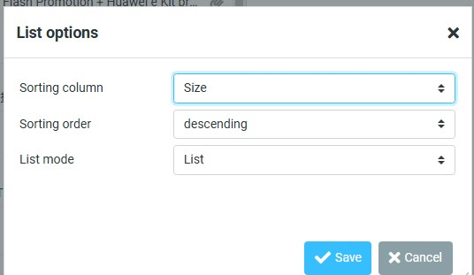
- While holding the Shift or Ctrl, select some biggest messages you want to delete
- click the Delete button
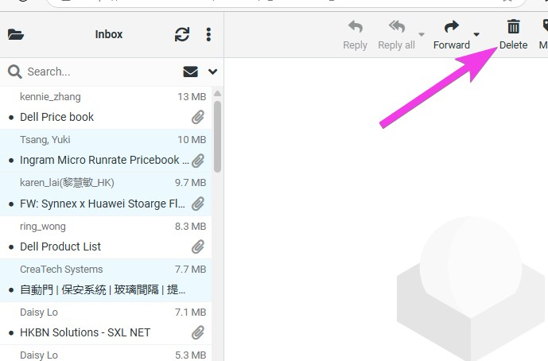
- Do the same for Sent folder
- After deleted messages, empty the Trash folder
- After few minutes (not immediately), notice the free space changed
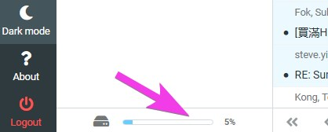
Tracedump:
newBaseSize: 16pt
newBaseSizeInPt: 16

