How to download Rustdesk
- Rustdesk is a software that let us control your computer to solve problems.
- open Microsoft Edge or any browser
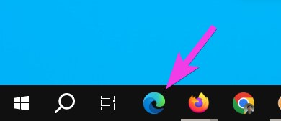
- type rustdesk.com in the address bar and press Enter
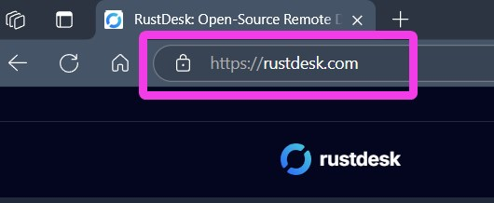
- click the big blue Download button
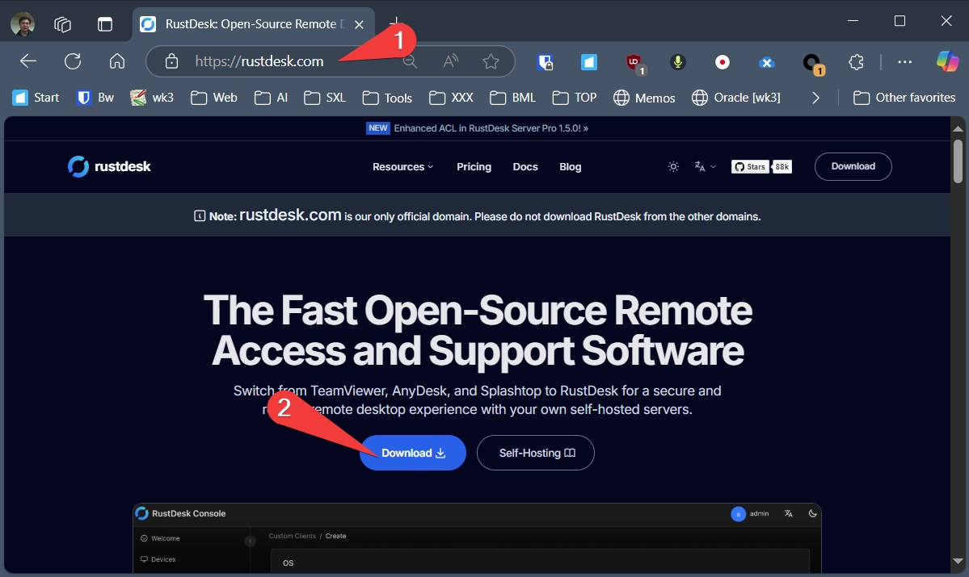
- If you are using Windows Computer, click the EXE under Windows x86-64 (64-bit)
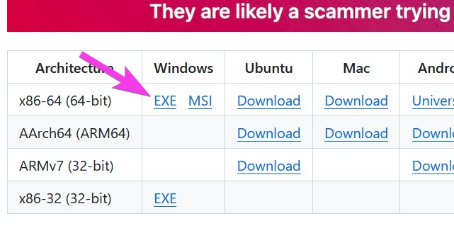
- Click Open
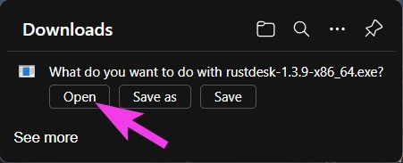
- Send us your ID via Whatsapp or Email or Phone call
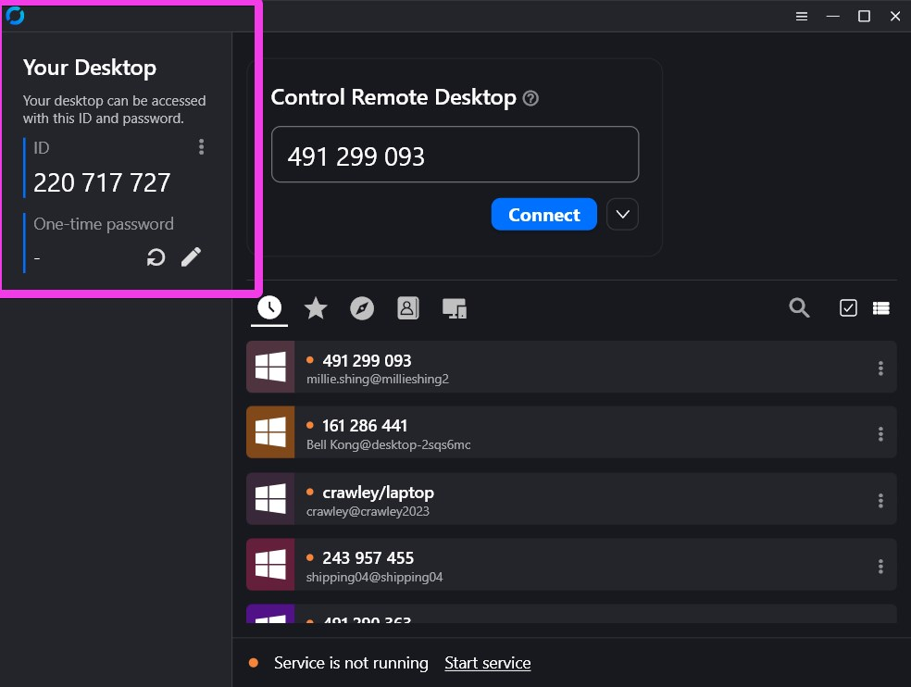
- When I connect to your computer please click Accept and Evaluate
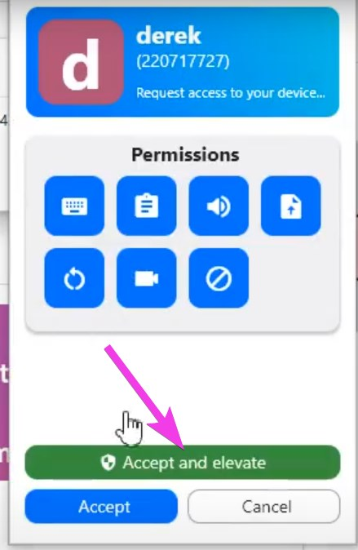
If you still have questions, please watch one of our tutorial video
- 广东话: https://youtu.be/INxaVwFpkzc
- English: https://youtu.be/1oGgf0HFeMs
- 普通话: https://youtu.be/IXSw8C2Y1zg
Tracedump:
newBaseSize: 16pt
newBaseSizeInPt: 16

